AN
INTERNSHIP REPORT
ON
CHAT APPLICATION
PROJECT
BY
SASWATI MAHAPATRA

INTRODUCTION
Today, developers around the world are working to improve user experience and make application design more efficient so projects can be delivered and updated within strict timelines. Technology stacks help build web applications quickly and are a response to the growing demands placed on software engineers. Many developers use pre-existing frameworks, including JavaScript, to simplify their work.
Among the many available stacks, MEAN and MERN are two popular options that have evolved from JavaScript. Both are made up of open-source components and provide an end-to-end framework for building complete web applications that allow browsers to connect with databases. Their main advantage is the use of a single programming language, JavaScript, which reduces syntax errors and confusion during coding. Another benefit of the MERN stack is its greater flexibility when developing web projects.
To understand the MERN stack, it is important to know its four main components: MongoDB, Express.js, React, and Node.js.

1.1) Problem Statement: -
this project is to create a chat application with a server and multiple users so they can communicate with each other. It aims to develop an instant messaging solution that allows seamless communication while remaining simple enough for even novice users to operate. Additionally, the project can play an important role in organizations by enabling employees to connect through a Local Area Network (LAN).
1.2) Objective: -
The main objective is to develop a user-friendly instant messaging system with an easy-to-use graphical user interface (GUI), allowing individuals with minimal technical knowledge to use the software efficiently. The messenger is designed to be platform-independent, meaning it can operate on any system regardless of the underlying operating system. It also supports unlimited clients, ensuring that many users can connect without causing server performance degradation. Overall, the goal is to provide a reliable, simple, and efficient communication tool for users.

CHAPTER-2
TECHNOLOGIES USED
2.1) What is MongoDB?
- MongoDB is a cross-platform document – oriented NoSQL database used for high volume data storage that provides high performance, high availability and easy scalability.
- MongoDB stores data in flexible, JSHON-like document, meaning fields can vary from document to document and data structure can be changed over time. The document model maps to the objects in the application code, making data easy to work with.
- The data model available within MongoDB allows users to represent heretical relationships, to store arrays, and other more complex structures more easily.
- MongoDB works on concept of collection and documents. Each database contains collections which in turn contains documents. Each document can have varying number of fields. The size and content of each document can also be different can also be different from each other.

2.2) What is Express.js?
- Express is a minimal and flexible Node.js web application framework that provides a robust set of features for web and mobile applications. It is an open-source framework development and maintained by the Node.js foundation.
- Express provides us the tools that are requires to build our app, be it single-page, multi-page pr hybrid web applications.
- Unlike its competitors like rails and Django, which have an opinionated way of building application, Express has no “best way” to do something it is very flexible and plugging
- Pug (earlier known as jade) Is a terse language for writing HTML templates. It produces HTML, supports dynamic code and code reusability (DRY). It is one of the most popular template languages used with Express.
- Express allows to dynamically render HTML pages based on passing arguments to templates.

Express is asynchronous and single threaded and performs I/O operation quickly.
2.3) What is react?
- ReactJS is a declarative, efficient, and flexible JavaScript library for building reusable UI components. It is an open-source, component-based front-end library which is responsible only for the view layer of the application. It was initially developed and maintained by Facebook and later used in its products like WhatsApp & Instagram.
- A ReactJS application is made up of multiple components, each component are the heart of all React applications are the heart of all React applications to be built of simple building blocks. ReactJS uses virtual DOM based mechanism to fill data in HTML DOM. The virtual DOM works fast as it only changes individual DOM elements instead of reloading complete DOM every time.
- Instead of using regular JavaScript, react codes are written in something called JSX (JavaScript Syntax Extension). JSX is basically a syntax extension of regular JavaScript and is used to create react elements. These elements are then rendered to the React DOM. JSX is faster than normal JavaScript as it performs optimization while translating to regular JavaScript.

CHAPTER-3
SYSTEM DESGINE & IMPLEMENTAION

This is a very basic web-based chat application and it is in its primary state. I have provided with a very easy to use GUI Interface.

3.1) GUI Interface
This is the GUI interface made using React.js etc

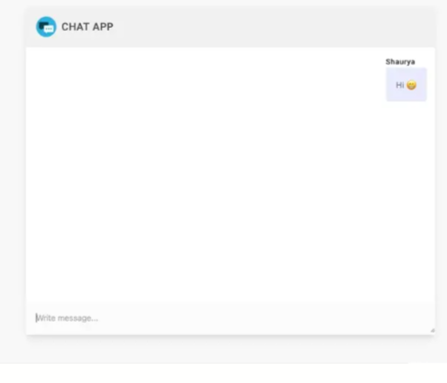
GUI Interface

CODE: -
HTML: -
<!DOCTYPE html>
<html>
<head>
<title>Message App</title>
<link rel="stylesheet" href="style.css">
</head>
<body>

<div class="box">
<h2>Message App</h2>

<div id="result"></div>

<input type="text" id="msg" placeholder="Type something">
<button onclick="addMessage()">Send</button>
</div>

<script src="script.js"></script>
</body>
</html>

STYLE.CSS: -
body{
background:#eccc68;
display:flex;
justify-content:center;
align-items:center;
height:100vh;
font-family:Arial;
}

.box{
background:white;
padding:20px;
width:300px;
border-radius:10px;
text-align:center;
}

#result{
height:150px;
border:1px solid gray;
margin-bottom:10px;
overflow-y:auto;
padding:5px;
}

.text{
background:#2ed573;
color:white;
padding:5px;
margin:5px;
border-radius:5px;
}

SCRIPT.JS: -
function addMessage(){

let message = document.getElementById("msg").value;

if(message !== ""){
let p = document.createElement("div");
p.className = "text";
p.innerText = message;

document.getElementById("result").appendChild(p);

document.getElementById("msg").value = "";
}
}

OUTPUT: -
Hello
How are you?
Good Morning

3.2) Implementation: -

A chat consists of two major parts:
- Chat App or client part, which is a Web chat application. Build on react
- Chat Server Engine or server part, which is a pool of external servers responsible for the chat operation. This is the place where all chat magic happens. Both parts contain various component that communication to each other and bring the chat into action.

CHAPTER-5
CONCLUSION

There is always a room for improvements in any apps and this being in its primary phase needs a load of it. But I will keep working on it and improving it with technological advancements in coming times. Right now, we are just dealing with text communication. There are several chat apps which server similar purpose as this application keeping in mind ease. A positive first impression is essential in human relationship as well as in human computer interaction. This project hopes to develops a chat service Web app with high quality user interface. In future we may be extended to include features such as file transfer, video message, audio and video call.

